Ref: SRMCEM/Placement/2025-26/009 Date: 28 Oct 2025

**Notice: Training & Placement Cell**

**Sub: Industrial Visit- STPI**

**Attn:BCA- 3rd Year**

Placement Cell is scheduling an Industrial Visit for **BCA – 3rd Year students to** STPI ,PGI Raibareli road, Lucknow, Uttar Pradesh.

The Schedule is as follows:

|  |  |  |  |  |  |
| --- | --- | --- | --- | --- | --- |
| **S.No** | **Branch** | **No of Students** | **Date of Visit** | **Reporting Time** | **Accompanying Faculty** |
| 1 | BCA- 3rd Year | 40 | Thursday  30 Oct, 2025 | 11.00 AM | Mr.Shadab Ali |

All the students of **BCA – 3rd Year** will go on this visit and they would be accompanied by **1 faculty**. The college bus will move at sharp **10.00 am** from **SRMCEM**, so as to reach to STPI,PGI, Lucknow, Uttar Pradesh, at **11.00 am positively.**

**Late comers will miss the bus.**

All the students should be in proper college uniform. Students should be punctual & well-disciplined during the visit. (Related instructions are enclosed herewith). **Faculties accompanying must take attendance of students visiting** and ensure interaction of the students with the industry.

Kindly coordinate with the **Administration Department** for transportation of the students. Also ensure that the feedback of the **Industrial visit** should be submitted to the **Placement Cell**, by the faculty member, after the visit by 31 Oct 2025along with photographsof the visit in **soft copy.**

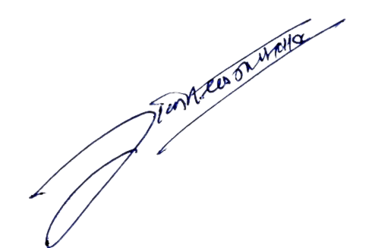

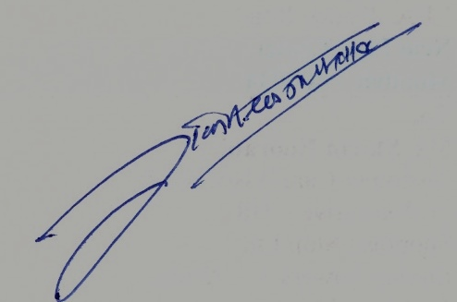

**Mr. R.C. Jaiswal**

**Director (Training & Placement)**

**Distribution:**

1..List A - All

2. List B – 2 4 17

3. List C –BCA

4. Respective Faculty Placement Coordinator